SHRI RAMDEOBABA COLLEGE OF ENGINEERING
AND MANAGEMENT, NAGPUR



Department of Computer Science & Engineering

PROJECT SYNOPSIS
Session: 2026–2027 | Semester: 7th | Programme: Honours / Minors

MEMORY-AUGMENTED TEMPORAL REASONING FOR FLOOD VICTIM DETECTION AND DYNAMIC RESCUE PRIORITY MAPPING FROM DRONE IMAGERY

Submitted by:

Prem Baba (53)
Purva Bhoyar (57)
Adhishree Shiledar (01)
Palak Zade (68)

Under the Guidance of:
Dr. Nisarg Gandhewar
(Associate Professor)

Date:
21 / 08 / 2027

1. Background and Motivation
Floods are among the most frequent and devastating natural disasters, affecting billions of people and causing large-scale loss of life. During a flood, rescue teams face two critical problems: many affected areas become physically unreachable due to submerged roads and dangerous currents, and responders lack real-time information on how many people are stranded and where. Ground-based search is slow, hazardous, and cannot quickly cover large inundated regions.
Unmanned Aerial Vehicles (UAVs) have become essential for disaster response, rapidly surveying inaccessible areas from above. However, most existing UAV systems perform a single task in isolation — detection, water segmentation, or scene classification — and describe only the present moment. They do not track victims over time, remember how each victim's situation is evolving, or produce an actionable, ranked rescue plan. Moreover, from drone altitude victims appear as tiny, often partially-occluded objects that standard detectors frequently miss — especially dangerous in rescue, where one missed detection can cost a life. This motivates an integrated, temporally-aware system that detects flood victims, reasons about their changing risk, and guides responders to the most critical locations first.
2. Problem Statement
Existing UAV flood-response solutions largely stop at single-frame detection or segmentation and do not provide rescue teams with a temporally-informed, prioritized decision output. There is a need for a system that detects stranded victims — including small and occluded targets — from drone imagery, tracks them across time, remembers how their situation is changing, incorporates flood severity, and produces a dynamic rescue-priority map. This project proposes an integrated framework combining aerial victim detection (humans, vehicles, and animals), multi-object tracking, short-term temporal memory, and flood-severity awareness to estimate a rescue-priority score for each affected location and generate an interpretable priority map that guides responders to the highest-risk victims first.
3. Objectives
- To build an aerial detector for stranded humans, vehicles, and animals, with special handling for tiny and partially-occluded targets using slicing-aided inference.
- To adapt a general aerial detector to flood conditions via two-stage training (pre-training on VisDrone, then fine-tuning on flood-specific data).
- To track detected victims across frames and maintain a short-term memory of each victim's evolving state (time stranded, movement, trend).
- To integrate flood-severity segmentation so that victims in more severely flooded areas are prioritized appropriately.
- To compute a rescue-priority score per location and generate a dynamic rescue-priority map with a victim summary.
- To evaluate the system against baseline detectors and through ablation studies measuring each module's contribution.
4. Literature Review and Research Gap
UAV-based flood response has advanced rapidly. Detection works such as RescueNet apply YOLO to identify and count flood survivors with high accuracy, while real-time methods additionally delineate flood extent and locate trapped pedestrians and vehicles. Datasets such as C2A provide synthetic disaster imagery, and FloodNet offers high-resolution UAV imagery for post-flood scene understanding. Recent studies compare YOLO variants for people on water and fine-tune detectors for rooftop victims, while supporting techniques like SAHI improve small-object detection and ByteTrack enables tracking. A consistent pattern emerges: each work addresses only one part of the problem. Most operate on single frames and stop at detection or counting; those with tracking target maritime settings or need thermal sensors; scene-level datasets do not localize or rank victims. The field also lacks a standard flood-victim benchmark.

Sr. | Author(s) & Year | Title / Focus | Methodology / Key Contribution | Limitation / Gap
1 | Prabhu et al., 2022 | RescueNet — flood survivor detection | YOLO-based detection and counting of flood survivors (mAP ~98%) | Single-frame; no tracking, memory, or prioritization
2 | Zhao et al., 2024 | Real-time rescue target detection for floods | Detects flood extent and trapped pedestrians/vehicles in real time | No temporal tracking, victim memory, or ranked priority
3 | Nihal et al., 2024 | C2A disaster human-detection dataset | Synthetic UAV disaster dataset; fine-tuning improves SAR detection | General disaster, not flood-specific; detection only
4 | Rahnemoonfar et al., 2021 | FloodNet — post-flood scene understanding | High-resolution UAV dataset for flood segmentation/classification | For scene understanding, not victim detection or ranking
5 | Nikitin et al., 2025 | YOLO models for flood human position | YOLO12 + optical flow + Kalman for people on water (mAP 0.95) | Maritime/water focus; no memory or priority mapping
6 | Fine-tuned study, 2025 | People detection in UAV building images | Fine-tuned YOLOv9 (~87%) for stranded rooftop/building victims | Detection only; no counting, tracking, or decision output
7 | Akyon et al., 2022 | SAHI — slicing-aided small-object detection | Slicing pipeline improving small-object detection and fine-tuning | A technique, not a full rescue system
8 | Zhang et al., 2022 | ByteTrack — multi-object tracking | Associates every detection box for robust multi-object tracking | Generic tracker; no flood context or prioritization
9 | Kyrkou & Theocharides, 2020 | AIDER — emergency-response classification | CNN classification of disaster scenes (fire, flood, collapse) | Scene-level only; no victim localization or ranking
10 | Hassan et al., 2024 | Aerial flood scene classification (South Asia) | YOLOv8 for humans/houses in flood imagery (~67% human acc.) | Low human accuracy; no tracking, memory, or priority
Table 1. Summary of Related Work and Identified Gaps

5. Proposed Methodology / Plan of Work
The system is a modular pipeline of two trained deep-learning models and three logic-based modules. Module 1 (Victim Detection) is a YOLOv8 detector identifying humans, vehicles, and animals. To catch the small, occluded targets typical of drone altitude, it uses slicing-aided inference (SAHI), high-resolution input, and occlusion-aware fine-tuning, and is built via two-stage training: pre-training on VisDrone for general overhead appearance, then fine-tuning on flood-specific imagery.
Module 2 (Tracking) applies ByteTrack to assign each victim a stable identity across frames. Module 3 (Short-Term Memory) keeps a per-victim history — time stranded, movement, and water trend — for reasoning about changing risk. Module 4 (Flood Severity) is a segmentation model trained on FloodNet estimating water extent per region. Module 5 (Risk & Priority) combines victim count, memory trend, isolation, and flood severity into a rescue-priority score and ranks all locations.
The output is a dynamic rescue-priority map with a victim summary and alerts. Development is incremental: the detection–tracking–memory–priority core is built and validated first to guarantee a working deliverable, after which flood-severity is added. Evaluation includes a baseline comparison, a VisDrone-only versus fine-tuned comparison, and ablations isolating memory and severity.
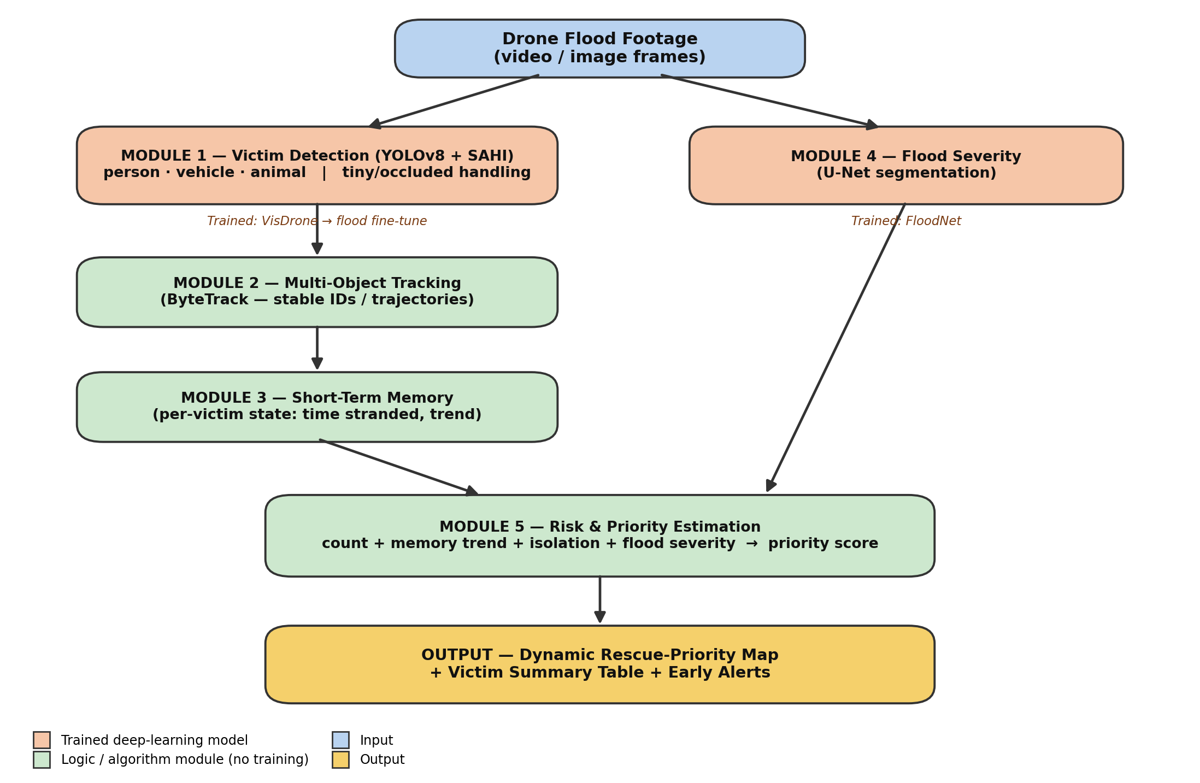
Figure 1. System Architecture of the Proposed Flood-Rescue Framework

6. Technology, Tools and Platforms
Category | Tools / Technologies
Language | Python
Detection | Ultralytics YOLOv8 + SAHI (slicing-aided small-object inference)
Tracking | ByteTrack (multi-object tracking)
Segmentation | U-Net-style network (flood-severity)
Frameworks / Libraries | PyTorch, OpenCV, NumPy
Datasets | VisDrone (base), Roboflow flood set (fine-tune), FloodNet (severity)
Platform | Google Colab / GPU-enabled workstation
Version Control | Git / GitHub

7. Expected Outcomes, Deliverables and Functional Specifications
The project will deliver a trained victim-detection model that detects and counts three classes (person, vehicle, animal) in aerial flood imagery with improved small-object detection over a plain-YOLO baseline, a flood-severity segmentation model that estimates water extent per region, and an integrated detection–tracking–memory–priority pipeline. Deliverables include the trained model weights, a documented Git repository, annotated output videos, a victim summary table (ID, class, location, risk, priority rank), a colour-coded rescue-priority map, and an evaluation report covering baseline-vs-proposed, VisDrone-only-vs-fine-tuned, and ablation comparisons (with and without memory and severity). Functionally, the system takes aerial flood video or images as input and outputs annotated frames, a priority map, and alerts; it maintains a stable unique ID for each victim across frames, computes a rescue-priority score from victim count, time-stranded trend, isolation, and flood severity, and ranks affected locations from Critical to Low.
8. Project Scope
The system targets drone-captured imagery of flood-affected areas and focuses on detecting and prioritizing visible stranded victims (humans, vehicles, animals) in open and semi-open flood scenes, as a decision-support tool for rescue teams and disaster command centres. It covers detection, tracking, short-term memory, flood-severity fusion, and priority mapping. It does not include control of the drone itself; dense-forest-canopy scenarios and multi-sensor fusion (thermal, GIS, live sensors) are out of scope and noted as future work, as are long-term historical-flood memory and minute-level future-risk forecasting.
9. Project Timeline
Phase | Duration | Milestone / Deliverable
Literature review & requirement analysis | Week 1 – 2 | Finalized problem, datasets, baseline study
Design & methodology finalisation | Week 2 – 3 | Architecture and module design frozen
Implementation / development | Week 3 – 6 | Detection, tracking, memory, severity, priority built
Testing & evaluation | Week 6 – 7 | Baseline comparison, ablations, metrics collected
Documentation & final submission | Week 7 – 8 | Report, results, and demo finalized
Table 2. Project Timeline and Milestones
10. References
[1] B. V. B. Prabhu, R. Lakshmi, R. Ankitha, M. S. Prateeksha, and N. C. Priya, "RescueNet: YOLO-based object detection model for detection and counting of flood survivors," Model. Earth Syst. Environ., vol. 8, no. 4, pp. 4509–4516, 2022.
[2] B. Zhao, H. Sui, and Y. Zhu, "Real-time rescue target detection based on UAV imagery for flood emergency response," J. Geodesy and Geoinformation Science, vol. 7, no. 1, pp. 74–89, 2024.
[3] R. A. Nihal, B. Yen, K. Itoyama, and K. Nakadai, "UAV-Enhanced Combination to Application: benchmarking of a human detection dataset for disaster scenarios," in Proc. Int. Conf. Pattern Recognition (ICPR), 2024.
[4] M. Rahnemoonfar, T. Chowdhury, A. Sarkar, D. Varshney, M. Yari, and R. R. Murphy, "FloodNet: a high-resolution aerial imagery dataset for post-flood scene understanding," IEEE Access, vol. 9, pp. 89644–89654, 2021.
[5] Comparative study, "Evaluation of YOLO models for human position recognition with UAVs during a flood," Applied System Innovation, vol. 9, no. 1, 2025.
[6] Fine-tuned deep models for people detection in UAV building images to aid flood rescue, Int. J. Applied Earth Observation and Geoinformation, 2025.
[7] F. C. Akyon, S. O. Altinuc, and A. Temizel, "Slicing aided hyper inference and fine-tuning for small object detection," in Proc. IEEE Int. Conf. Image Processing (ICIP), 2022.
[8] Y. Zhang et al., "ByteTrack: multi-object tracking by associating every detection box," in Proc. European Conf. Computer Vision (ECCV), 2022.
[9] C. Kyrkou and T. Theocharides, "Deep-learning-based aerial image classification for emergency response applications using UAVs (AIDER)," in Proc. IEEE CVPR Workshops, 2020.
[10] I. Hassan et al., "Aerial flood scene classification using fine-tuned attention-based architecture for flood-prone countries in South Asia," arXiv:2411.00169, 2024.
Group Member Details
Branch | Roll No. | Name and Signature of Student
CSE | 53 | Prem Baba
CSE | 57 | Purva Bhoyar
CSE | 01 | Adhishree Shiledar
CSE | 68 | Palak Zade
Approved by:
Dr. Nisarg Gandhewar
(Associate Professor)

Signature: ______________________

